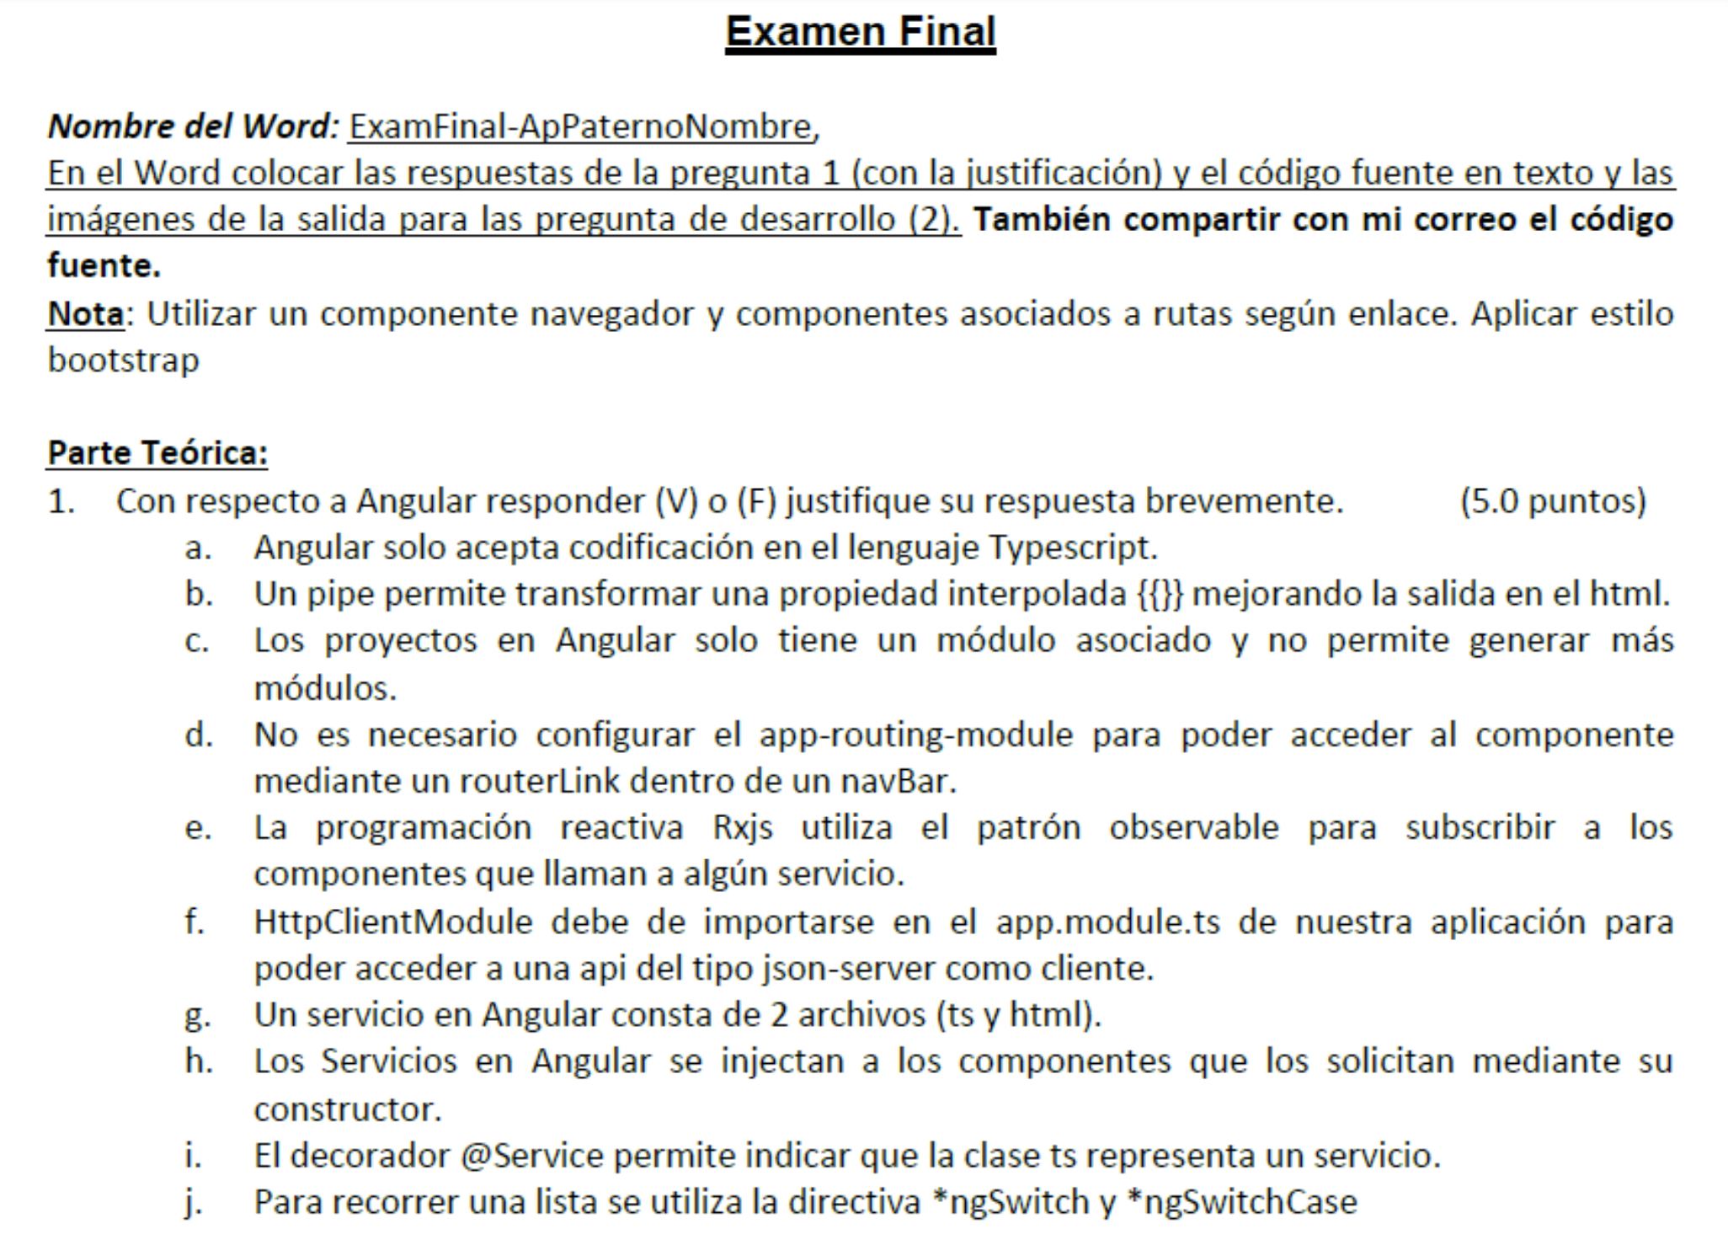

1. (F) Angulat permite utilzar codigo typescript principalmente, pero tambien javascript.
2. (V) Permite formatear o transformar data en un formato o forma especifico.
3. (F) Angular es modular, por lo que se pueden crear multiples modulos paralelos o anidados
4. (F) Si es necesario y es la que contendrá las rutas de mi proyecto que posteriormente agregaré en en un navBar.
5. (V) Si mediante la librería rxjs
6. (V) Si en neceaario para que se aprovisione correctamente.
7. (F) Un service en angular solo consta de un typescript principalmente, tambien se puede incluir de manera opcional su contraparte correspondiente a test. .espec.ts
8. (V) Para poder tenerlos en la clase completa y se puede agregar nivel de acceso public o private.
9. (F) Sería el decordaror:

@Injectable({

providedIn: 'root'

})

1. (F) Sería ngFor

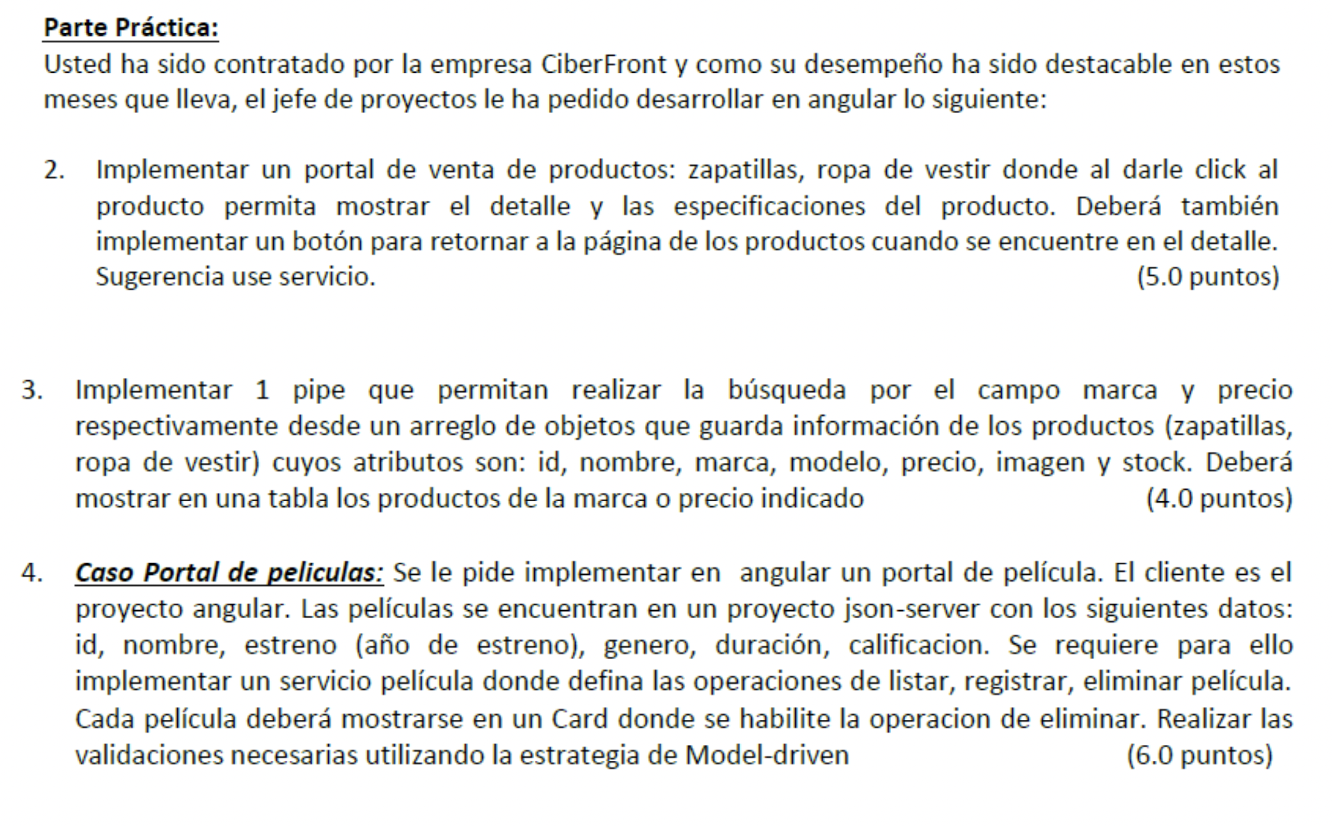

Componente Principal: HTML y TS

<main class="flex-shrink-0">

<!-- Navigation-->

<nav class="navbar navbar-expand-lg navbar-dark bg-dark">

<div class="container px-5">

<a class="navbar-brand" rel="canonical" routerLink="/">{{ this.getAppNameEnvironment() }}</a>

<button class="navbar-toggler" type="button" data-bs-toggle="collapse" data-bs-target="#navbarSupportedContent" aria-controls="navbarSupportedContent" aria-expanded="false" aria-label="Toggle navigation"><span class="navbar-toggler-icon"></span></button>

<div class="collapse navbar-collapse" id="navbarSupportedContent">

<ul class="navbar-nav ms-auto mb-2 mb-lg-0">

<li class="nav-item"><a class="nav-link" rel="canonical" routerLink="/"><i class="pi pi-home"></i> {{ 'public.nav.home' | translate }}</a></li>

<li class="nav-item"><a class="nav-link" rel="canonical" routerLink="/movies"><i class="pi pi-forward"></i> {{ 'public.nav.movies' | translate }}</a></li>

<li class="nav-item"><a class="nav-link" rel="canonical" routerLink="/shop"><i class="pi pi-shopping-bag"></i> {{ 'public.nav.shop' | translate }}</a></li>

<li class="nav-item"><a class="nav-link" rel="canonical" routerLink="/cart"><i class="pi pi-shopping-cart"></i> {{ 'public.nav.cart' | translate }}</a></li>

<li class="nav-item"><a class="nav-link" *ngIf="this.isLogged()" style="cursor: pointer;" (click)="logout()"><i class="pi pi-sign-out"></i> {{ 'public.nav.logout' | translate }}</a></li>

<li class="nav-item"><a class="nav-link" *ngIf="!this.isLogged()" rel="canonical" routerLink="/login"><i class="pi pi-user"></i> {{ 'public.nav.login' | translate }}</a></li>

</ul>

</div>

</div>

</nav>

<router-outlet></router-outlet>

</main>

<!-- Footer-->

<footer class="bg-dark py-4 mt-auto">

<div class="container px-5">

<div class="row">

<div class="col-sm-6">

<h6 class="h5 m-0 text-white" *ngIf="showCountries">{{ 'public.footer.title_countries' | translate }}</h6>

<ul class="m-2" *ngIf="showCountries">

<li *ngFor="let country of this.countries"><a class="link-light small" style="cursor: pointer;" (click)="this.changeCountry(country)">{{ country.countryLabel }}</a></li>

</ul>

</div>

<div class="col-sm-6">

<h6 class="h5 m-0 text-white">{{ 'public.footer.title_languages' | translate }}</h6>

<ul class="m-2">

<li *ngFor="let language of this.languages"><a class="link-light small" style="cursor: pointer;" (click)="this.changeLanguage(language)">{{ language.name }}</a></li>

</ul>

</div>

</div>

</div>

</footer>

import { Component, Inject, OnInit } from '@angular/core';

import { DOCUMENT } from '@angular/common';

import { CountriesConfigService } from 'src/app/services/util/countries-config.service';

import { CountryConfig, LanguageConfig } from 'src/app/interfaces/Util/countries-config';

import { environment } from 'src/environments/environment';

@Component({

selector: 'app-main',

templateUrl: './main.component.html',

styleUrls: ['./main.component.css']

})

export class MainComponent implements OnInit {

countries: CountryConfig[] = []

currentCountry: CountryConfig

showCountries: boolean = false

languages: LanguageConfig[] = []

constructor(

private serviceCountryConfig: CountriesConfigService,

@Inject(DOCUMENT) private document: Document

) {

this.currentCountry = {

name: '',

country: '',

countryLabel: '',

uri: ''

}

}

ngOnInit(): void {

this.loadCountryNav()

this.loadLanguageFooter()

}

isLogged() {

if(

localStorage.getItem('displayName') == null ||

localStorage.getItem('token') == null

) {

return false

}

else {

return true

}

}

loadCountryNav() {

let country = localStorage.getItem('country')

this.serviceCountryConfig.getCountries().subscribe( (config: CountryConfig[]) => {

this.countries = config.filter(d => { return d.country != localStorage.getItem('country') })

this.currentCountry = config.filter(d => { return d.country == country })[0]

if(this.countries.length > 0 && this.currentCountry.country != ''){

this.showCountries = true

}

else {

this.showCountries = false

}

})

}

getCurrentCountry() {

return this.currentCountry.countryLabel

}

loadLanguageFooter() {

let current = this.document.documentElement.lang

this.serviceCountryConfig.getLanguages(localStorage.getItem('country')!).subscribe( (config: LanguageConfig[]) => {

this.languages = config.filter(lan => {return lan.abrev != current})

})

}

changeLanguage(language: LanguageConfig) {

this.document.documentElement.lang = language.abrev

localStorage.setItem('language', language.abrev)

window.location.reload()

}

changeCountry(country: CountryConfig) {

localStorage.setItem('country', country.country)

window.location.reload()

}

getAppNameEnvironment() {

return environment.appName

}

logout() {

localStorage.removeItem('displayName')

localStorage.removeItem('token')

}

}

Componente Shop: HTML y TS

<section class="pt-5">

<div class="d-grid gap-2 d-md-block mx-auto text-center">

<h1 class="fw-bolder">Tienda de ropa</h1>

</div>

</section>

<section class="py-5">

<div class="container px-5">

<div class="row gx-5">

<div class="col-lg-4 mb-5" *ngFor="let entry of this.entries">

<div class="card h-100 shadow border-0">

<img class="card-img-top p-5" src="{{ entry.imagen }}" alt="{{ entry.nombre }}" />

<div class="card-body p-4">

<div class="badge bg-primary bg-gradient rounded-pill mb-2">{{ entry.marca }}</div>

<div class="badge bg-warning bg-gradient rounded-pill mb-2">{{ entry.categoria }}</div>

<div class="badge bg-success bg-gradient rounded-pill mb-2">{{ entry.precio | currency: 'PEN': 'symbol': '' }}</div>

<a class="text-decoration-none link-dark stretched-link" href="/shop/detail/{{entry.id}}"><div class="h5 card-title mb-3">{{ entry.nombre }}</div></a>

</div>

</div>

</div>

</div>

<div class="text-center mb-5 mb-xl-0" *ngIf="showCharging">

<i class="pi pi-spin pi-spinner" style="font-size: 2rem"></i>

</div>

<div class="text-end mb-5 mb-xl-0 text-center" *ngIf="!showCharging">

<button [hidden]="!showMore" class="btn btn-primary" (click)="this.getMoreEntries()">Ver más</button>

</div>

</div>

</section>

import { Component, OnInit } from '@angular/core';

import { ProductEntry } from 'src/app/interfaces/content/products';

import { ProductsService } from 'src/app/services/content/products.service';

import { SeoService } from 'src/app/services/util/seo.service';

@Component({

selector: 'app-shop',

templateUrl: './shop.component.html',

styleUrls: ['./shop.component.css']

})

export class ShopComponent implements OnInit {

entries: ProductEntry[] = []

showCharging: boolean = false

showMore: boolean = true

page: number = 1

constructor(

private SEOService: SeoService,

private service: ProductsService

) { }

ngOnInit(): void {

this.SEOService.updateTitle('Inicio | Sistema de io data perú');

this.SEOService.updateDescription('Description del sitio para el sistema publicado. Description del sitio para el sistema publicado. Description del sitio para el sistema publicado. ');

this.SEOService.updateRobot('index, follow')

this.SEOService.updateKeywords('apps, otros')

this.SEOService.updateAuthor('IO Data Perú')

this.SEOService.updatePublisher('IO Data Perú')

this.SEOService.createCanonicalLink()

this.getListEntries()

}

getListEntries(){

this.showCharging = true

let size = 6

this.service.list(this.page, size).subscribe((response: ProductEntry[]) => {

this.page += 1;

this.entries.push(...response)

this.showCharging = false

if(response.length < size){

this.showMore = false

}

}, (error) => {

console.log("ERROR")

this.showCharging = false

})

}

getMoreEntries(){

this.showCharging = true

setTimeout(() => {this.getListEntries()}, 1000)

}

}

Componente Shop Detail: HTML y TS

<!-- Page Content-->

<section class="pt-5">

<div class="d-grid gap-2 d-md-block mx-auto text-center">

<h1 class="fw-bolder">{{ entry.nombre }}</h1>

</div>

</section>

<!-- Blog preview section-->

<section class="py-5">

<div class="container px-5">

<div class="row gx-5">

<div class="col-lg-6 mb-5">

<div class="card h-100 shadow border-0">

<img class="card-img-top p-3" src="{{ entry.imagen }}" alt="{{ entry.nombre }}" />

</div>

</div>

<div class="col-6">

<button class="btn btn-warning mb-1" (click)="this.back()"><i class="pi pi-angle-left"></i>Regresar</button>

<div class="inline" *ngIf="!added">

<button class="btn btn-primary" (click)="this.disminuir()">-</button>

<span class="btn border">{{ count }}</span>

<button class="btn btn-primary" (click)="this.aumentar()">+</button>

<button class="btn btn-success m-2" (click)="this.agregar()">Agregar al carrito</button>

</div>

<div class="mx-auto" *ngIf="added">

<a class="btn btn-primary" [routerLink]="'/cart'">Ir al carrito</a>

</div>

<div class="h5 card-title my-3">{{ entry.nombre }}</div>

<div class="h6 card-title my-3">Marca: {{ entry.marca }}</div>

<div class="h2 card-title mb-3">PRECIO: {{ entry.precio | currency: 'PEN': 'symbol': '' }}</div>

<div class="badge bg-primary bg-gradient rounded-pill mb-2">{{ entry.categoria }}</div>

<p class="card-text mb-0">{{ entry.detalle }}</p>

</div>

</div>

</div>

</section>

import { Component, OnInit } from '@angular/core';

import { ActivatedRoute, Router } from '@angular/router';

import { ProductEntry } from 'src/app/interfaces/content/products';

import { ProductsService } from 'src/app/services/content/products.service';

import { SeoService } from 'src/app/services/util/seo.service';

@Component({

selector: 'app-shop-detail',

templateUrl: './shop-detail.component.html',

styleUrls: ['./shop-detail.component.css']

})

export class ShopDetailComponent implements OnInit {

entry: ProductEntry = <ProductEntry>{

id: 0,

nombre: '',

marca: '',

categoria: '',

imagen: '',

detalle: '',

precio: 0

};

count = 1

added: boolean = false

constructor(

private router: Router,

private route: ActivatedRoute,

private SEOService: SeoService,

private service: ProductsService

) { }

ngOnInit(): void {

this.getProductDetail()

}

getProductDetail() {

this.route

.paramMap

.subscribe(params => {

this.service.get(Number(params.get('id'))).subscribe((response: ProductEntry) => {

this.entry = response

this.added = (this.service.existProductInCart(this.entry.id));

})

})

}

aumentar() {

this.count += 1;

}

disminuir() {

this.count = this.count == 1 ? 1 : this.count-1;

}

agregar() {

this.service.addToCart({product: this.entry.id, quantity: this.count})

this.getProductDetail()

}

back() {

this.router.navigate(['/shop'])

}

}

Service:

import { HttpClient } from '@angular/common/http';

import { Injectable } from '@angular/core';

import { Observable } from 'rxjs';

import { ItemCart } from 'src/app/interfaces/content/cart-items';

import { ProductEntry } from 'src/app/interfaces/content/products';

import { environment } from 'src/environments/environment';

@Injectable({

providedIn: 'root'

})

export class ProductsService {

items: ItemCart[] = [];

constructor(

private httpClient: HttpClient

) {

}

list(init: number, limit: number): Observable<ProductEntry[]> {

return this.httpClient.get<ProductEntry[]>(environment.apiUrl + '/products', {params: {"_page": init, "_limit": limit}});

}

get(code: number): Observable<ProductEntry> {

return this.httpClient.get<ProductEntry>(environment.apiUrl + '/products/' + code);

}

getCart() {

this.items = JSON.parse(localStorage.getItem("cart_items") || '[]') ?? []

return this.items

}

addToCart(item: ItemCart) {

this.items = JSON.parse(localStorage.getItem("cart_items") || '[]') ?? []

if(this.items.filter(e => {return e.product==item.product}).length == 0){

this.items.push(item)

localStorage.setItem('cart_items', JSON.stringify(this.items));

}

}

deleteToCart(itemID: number) {

this.items = JSON.parse(localStorage.getItem("cart_items") || '[]') ?? []

this.items = this.items.filter(e => {return e.product!=itemID})

localStorage.setItem('cart_items', JSON.stringify(this.items));

}

clearCart() {

this.items = []

localStorage.setItem('cart_items', JSON.stringify(this.items));

}

existProductInCart(productID: number) {

this.items = JSON.parse(localStorage.getItem("cart_items") || '[]') ?? []

return (this.items.filter(e => {return e.product==productID}).length > 0)

}

}

Resultado:

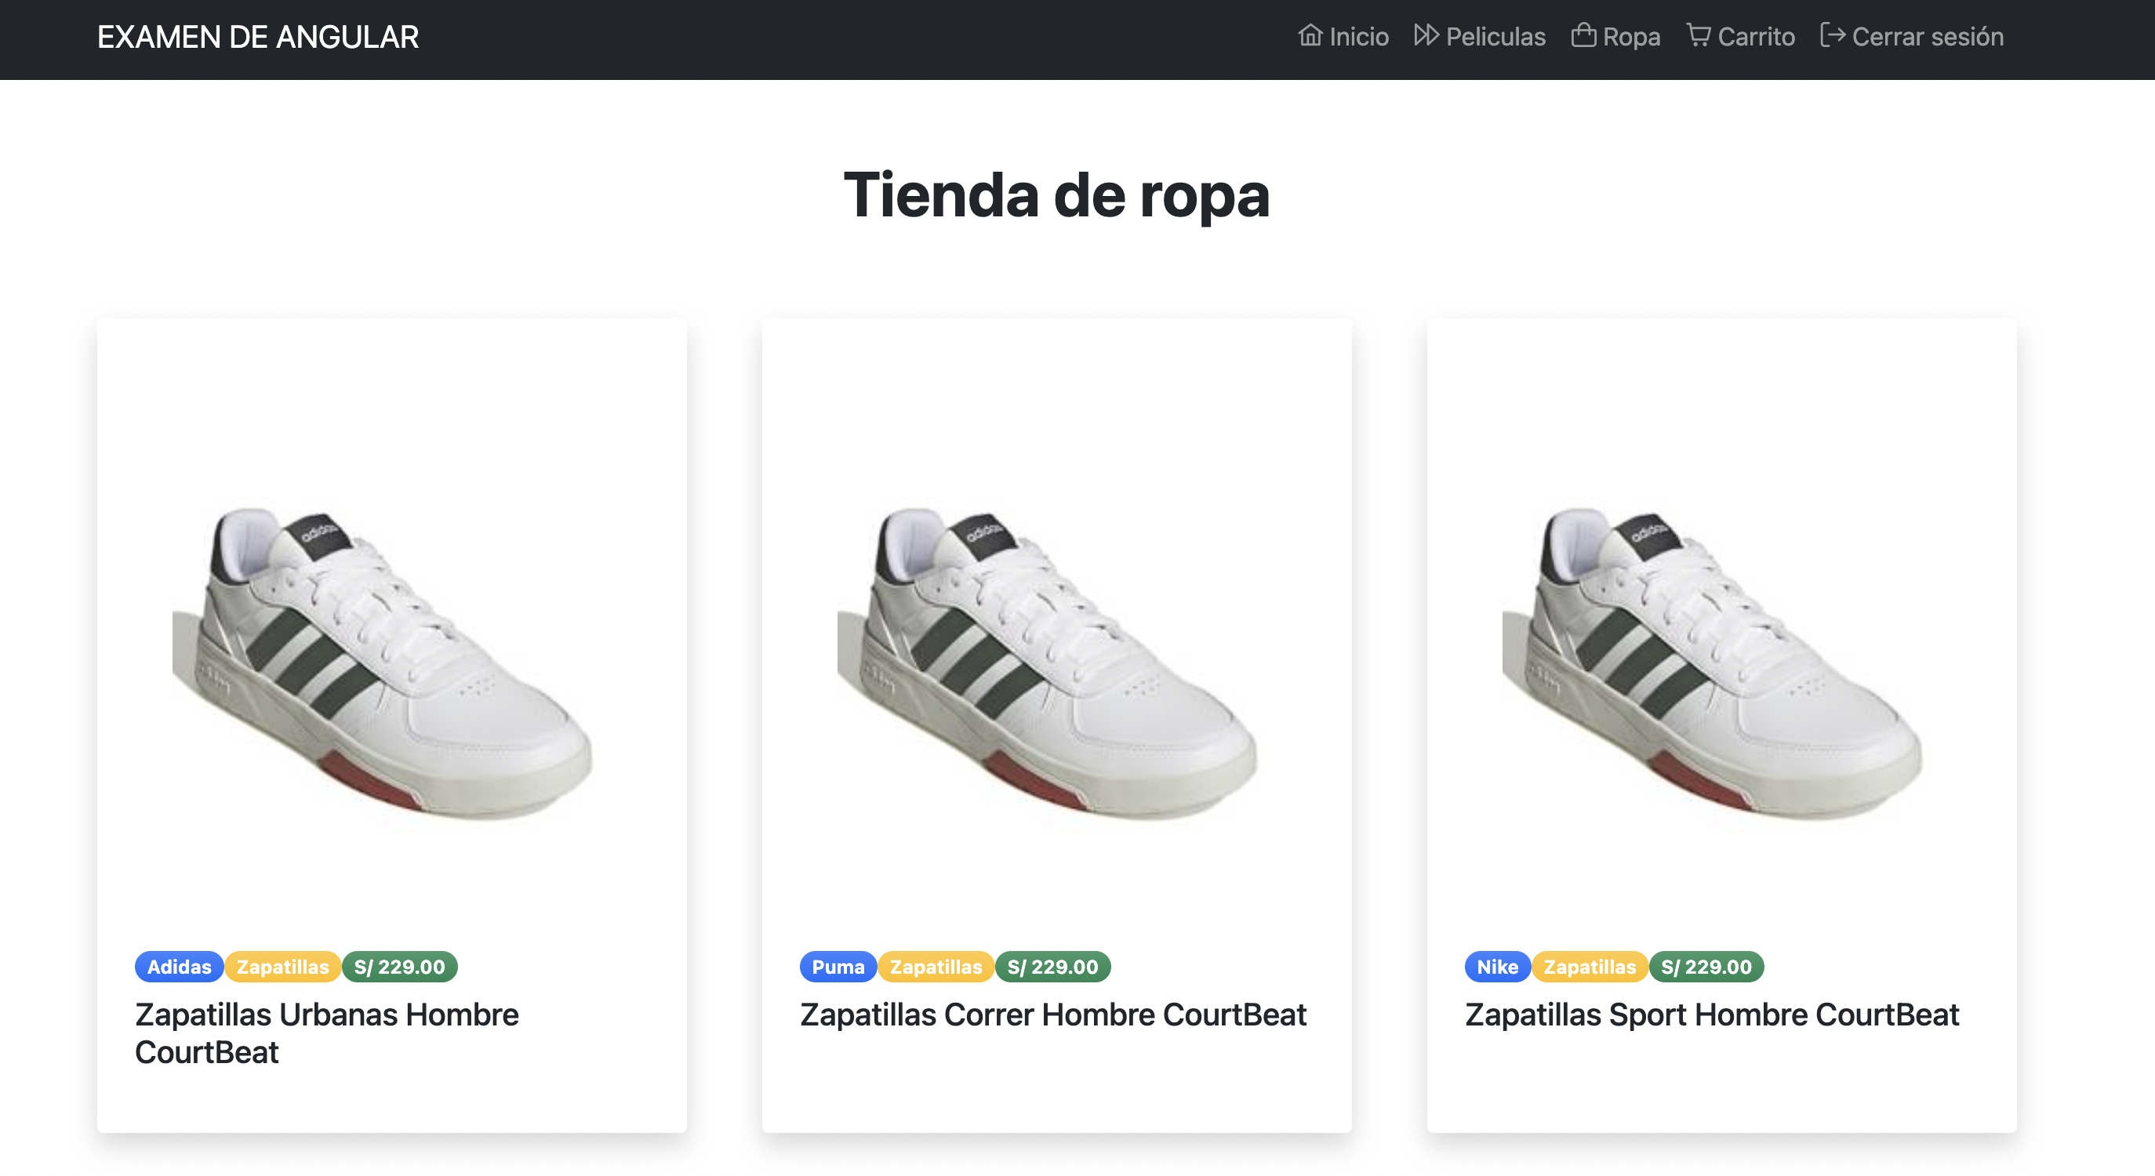

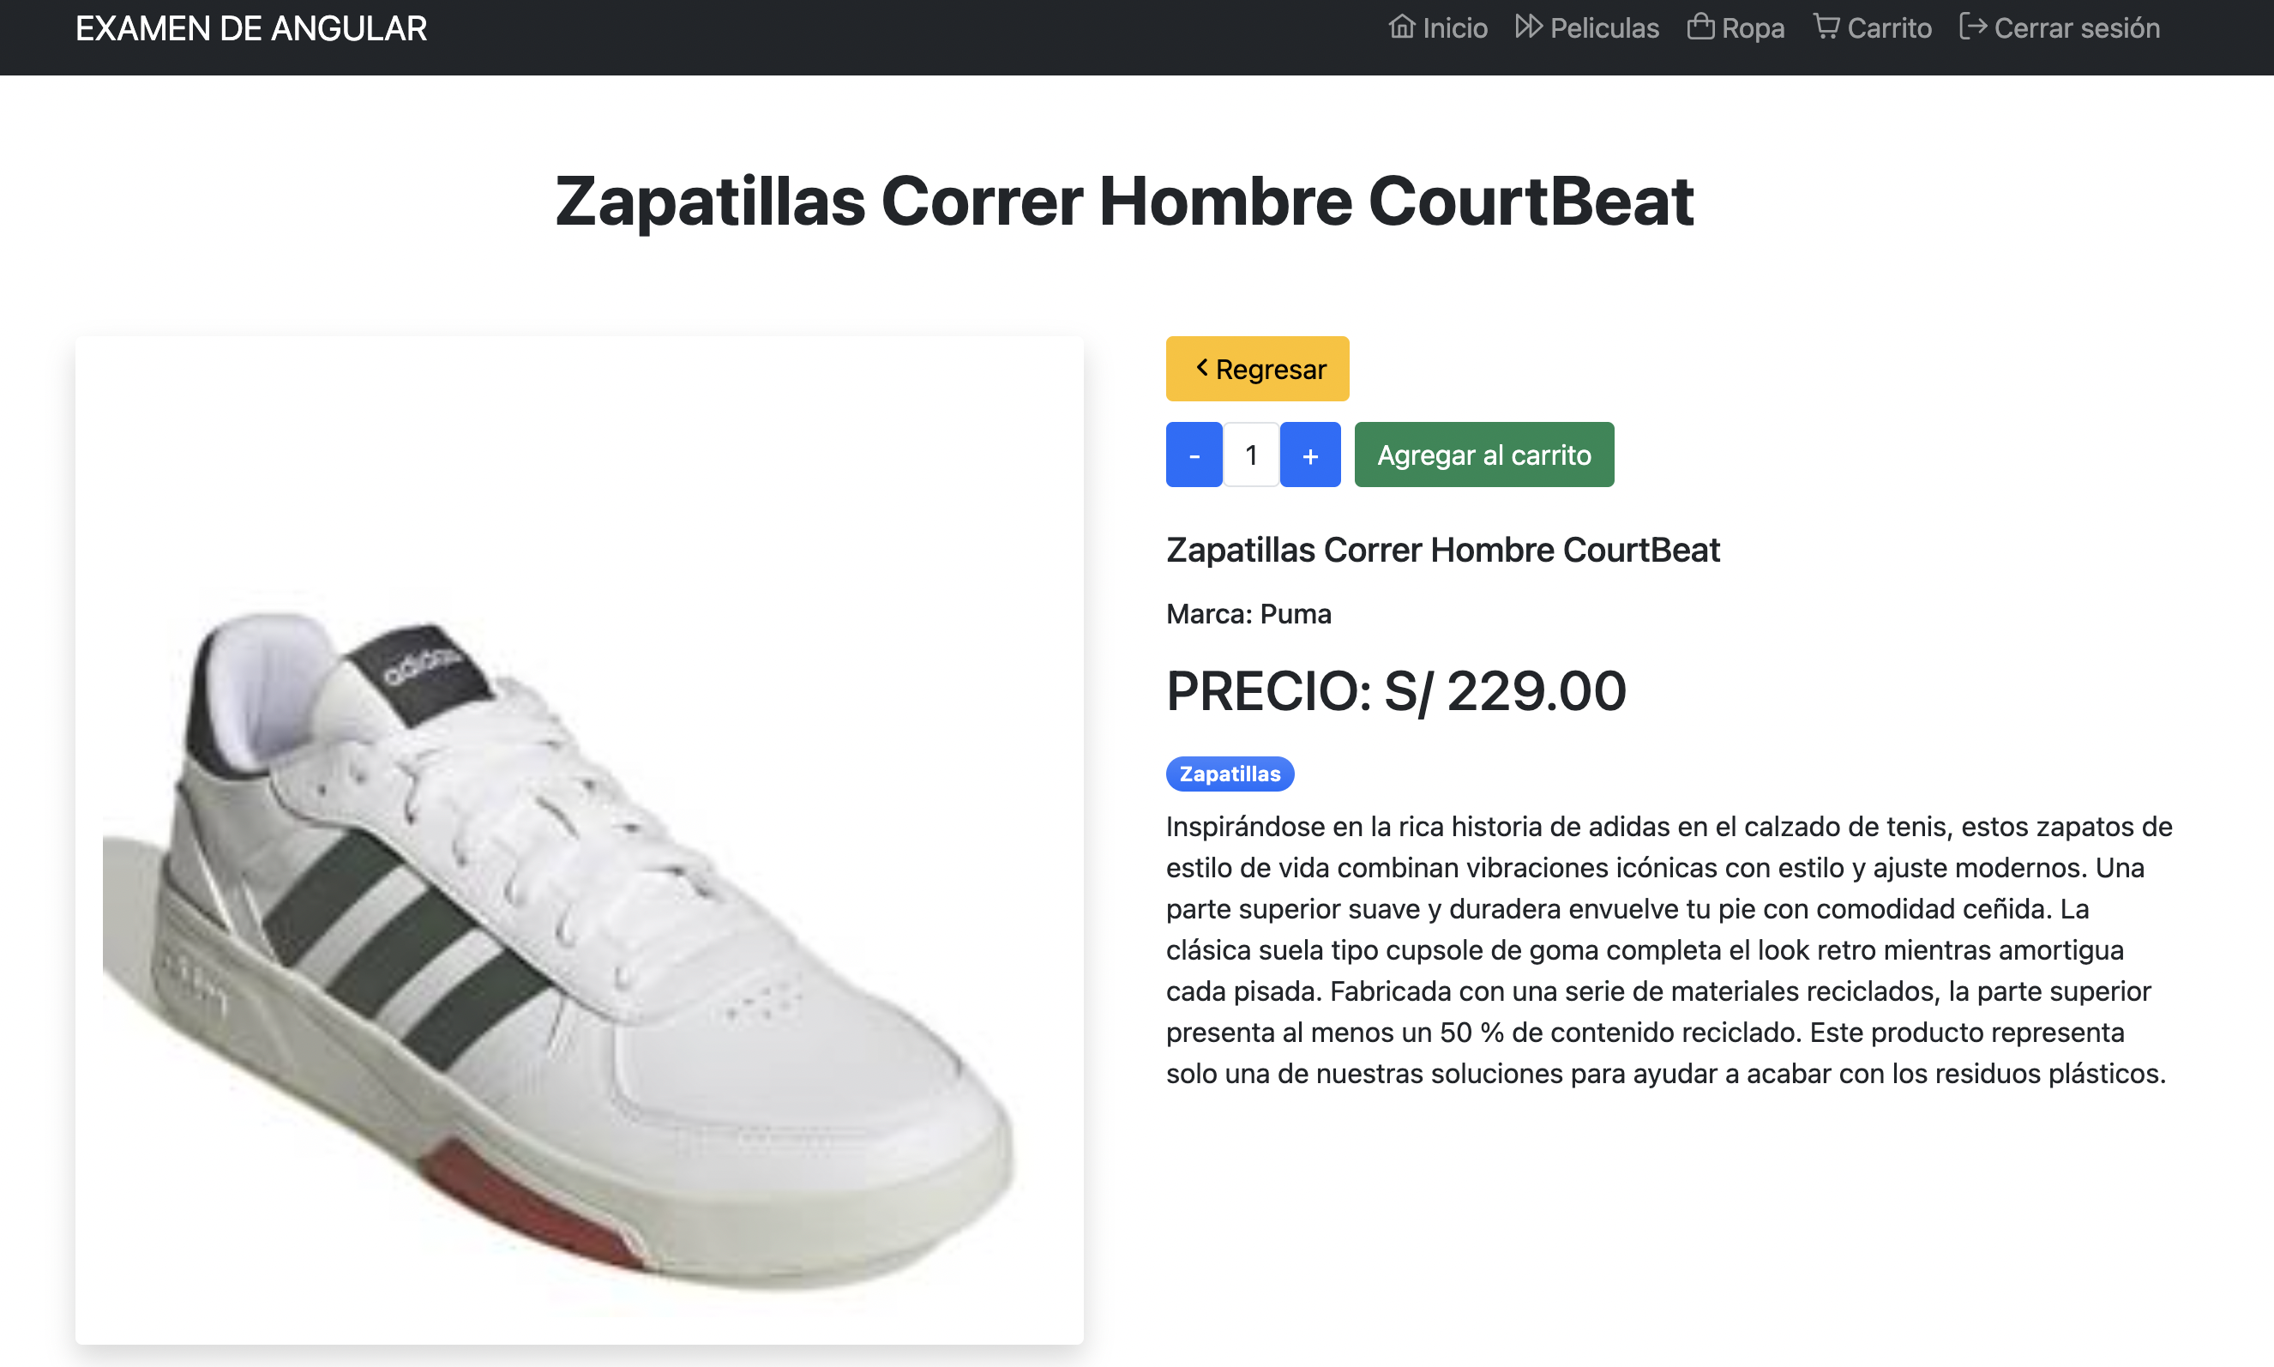



Componente Search: HTML y TS

<!-- Page Content-->

<section class="pt-5">

<div class="d-grid gap-2 d-md-block mx-auto text-center">

<h1 class="fw-bolder">Carrito de compra</h1>

</div>

</section>

<!-- Page Content-->

<section class="px-5">

<div class="d-grid gap-2 d-md-block mx-auto text-center px-5">

<div class="form-group px-5">

<div class="alert alert-primary" role="alert" *ngIf="products.length == 0">

Agregue productos desde <a routerLink="/shop">la tienda de ropa</a>

</div>

<input type="email" class="form-control" placeholder="Buscar por marca o precio" [readonly]="products.length == 0" [(ngModel)]="searching">

</div>

</div>

</section>

<!-- Blog preview section-->

<section class="py-5">

<div class="container px-5">

<div class="row gx-5">

<div class="col-lg-12 mb-5">

<p-table [value]="products | searching:searching" responsiveLayout="scroll">

<ng-template pTemplate="header">

<tr>

<th>Nombre</th>

<th>Marca</th>

<th>Categoria</th>

<th>Imagen</th>

<th>Precio und</th>

<th>Cantidad</th>

<th>Precio total</th>

<th></th>

</tr>

</ng-template>

<ng-template pTemplate="body" let-product>

<tr>

<td>{{product.nombre}}</td>

<td>{{product.marca}}</td>

<td>{{product.categoria}}</td>

<td [width]="120"><img src="{{product.imagen}}" alt="{{product.nombre}}" class="img-thumbnail"></td>

<td>{{product.precio | currency: 'PEN': 'symbol': '' }}</td>

<td>{{product.quantity}}</td>

<td>{{ (product.precio*product.quantity) | currency: 'PEN': 'symbol': '' }}</td>

<td><button class="btn btn-danger" (click)="this.delete(product.id)">X</button></td>

</tr>

</ng-template>

</p-table>

</div>

</div>

</div>

</section>

<!-- Page Content-->

<section class="pb-5">

<div class="d-grid gap-2 d-md-block mx-auto text-center">

<button class="btn btn-danger btn-lg mb-5" (click)="this.clear()" *ngIf="products.length > 0">Borrar el carrito</button>

<h5 class="fw-bolder">Cliente {{ this.getUsername() }}</h5>

<h2 class="fw-bolder">

Total a pagar: {{ total | currency: 'PEN': 'symbol': '' }}

</h2>

<div class="alert alert-warning" role="alert" *ngIf="!this.isLogged()">

Para poder pagar <a routerLink="/login">INICIA SESIÓN</a>

</div>

<button class="btn btn-success btn-lg mb-5" (click)="this.pagar()" [disabled]="!this.isLogged()">PAGAR</button>

</div>

</section>

import { Component, OnInit } from '@angular/core';

import { ItemCart, ProductCart } from 'src/app/interfaces/content/cart-items';

import { ProductEntry } from 'src/app/interfaces/content/products';

import { ProductsService } from 'src/app/services/content/products.service';

@Component({

selector: 'app-search',

templateUrl: './search.component.html',

styleUrls: ['./search.component.css']

})

export class SearchComponent implements OnInit {

products: ProductCart[] = []

total: number = 0

searching: string = ''

constructor(

private service: ProductsService

) { }

ngOnInit(): void {

this.loadCart()

}

loadCart(){

this.service.getCart().map( item => {

this.service.get(item.product).subscribe((response: ProductEntry) => {

this.products.push(<ProductCart>{

id: response.id,

nombre: response.nombre,

marca: response.marca,

categoria: response.categoria,

imagen: response.imagen,

precio: response.precio,

quantity: item.quantity

})

this.total += (item.quantity * response.precio)

})

})

}

delete(code: number){

this.service.deleteToCart(code)

this.products = []

this.total = 0

this.searching = ''

this.loadCart()

}

isLogged() {

if(

localStorage.getItem('displayName') == null ||

localStorage.getItem('token') == null

) {

return false

}

else {

return true

}

}

pagar() {

this.clear()

}

clear() {

this.service.clearCart()

this.products = []

this.total = 0

this.loadCart()

}

getUsername() {

return localStorage.getItem('displayName')

}

}

Pipe Searching

import { Pipe, PipeTransform } from '@angular/core';

import { ProductCart } from '../interfaces/content/cart-items';

@Pipe({

name: 'searching'

})

export class SearchingPipe implements PipeTransform {

transform(value: ProductCart[], consulta: string): ProductCart[] {

if(consulta === '') return value;

return value.filter((p) => {

return (

p.marca.toLowerCase().indexOf(consulta.toLowerCase())>-1 ||

p.precio.toString().indexOf(consulta.toLowerCase())>-1

)

})

}

}

Modelo Producto

export interface ProductCart {

id: number,

nombre: string,

marca: string,

categoria: string,

imagen: string,

precio: number,

quantity: number

}

Resultado

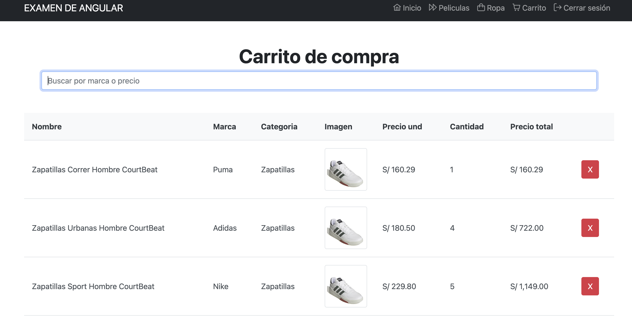

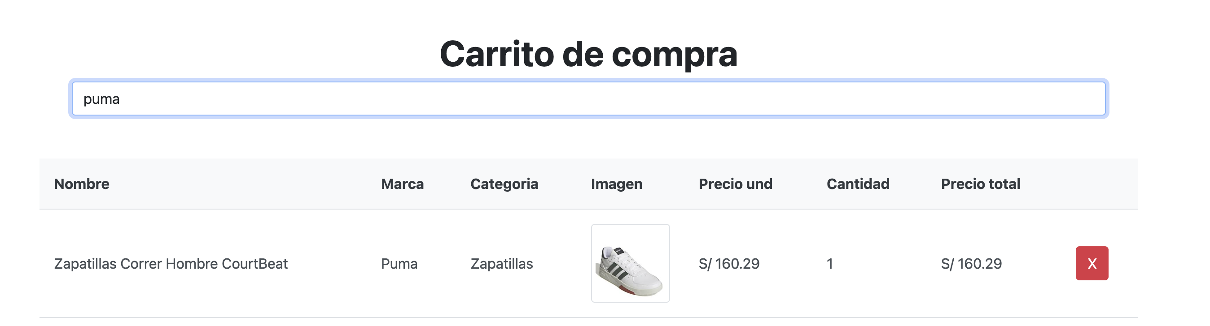

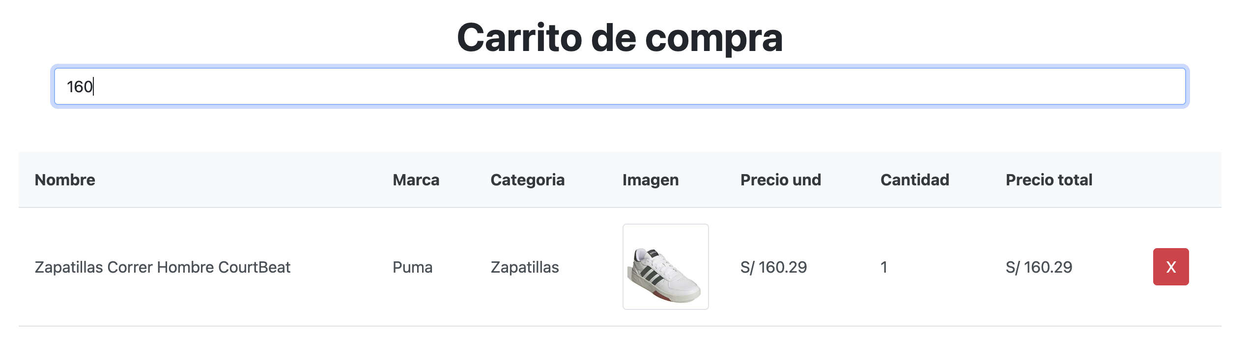



JSON

{

"movies": [

{

"nombre": "Dahmer Monstruo: La historia de Jeffrey Dahmer",

"genero": "Crimen - Drama",

"estreno": 2022,

"duracion": 110,

"director": "Ryan Murphy",

"imagen": "https://image.tmdb.org/t/p/w300/vlUMBgKO1HOwPMJwHnHzr99BHwN.jpg?x79441",

"calificacion": 9,

"id": 1

},

{

"nombre": "RRR (2022)",

"genero": "Acción - Bélica - Drama",

"estreno": 2022,

"duracion": 110,

"director": "S. S. Rajamouli",

"imagen": "https://image.tmdb.org/t/p/w300/hmDNYJkVdooSTNej2AnWV0nbH3q.jpg?x79441",

"calificacion": 7,

"id": 2

},

{

"nombre": "Smile (2022)",

"genero": "Misterio - Suspense - Terror",

"estreno": 2022,

"duracion": 110,

"director": "Parker Finn",

"imagen": "https://image.tmdb.org/t/p/w300/aw05OSgJFxsMiLAN0UQG2gCdTGY.jpg?x79441",

"calificacion": 4,

"id": 3

}

]

}

Componente Movies: HTML y TS

<!-- Page Content-->

<section class="pt-5">

<div class="d-grid gap-2 d-md-block mx-auto text-center">

<h1 class="fw-bolder">Peliculas</h1>

<button class="btn btn-success" (click)="this.showDialog()">Agregar nueva pelicula</button>

</div>

</section>

<!-- Blog preview section-->

<section class="py-5">

<div class="container px-5">

<div class="row gx-5">

<div class="col-lg-3 mb-5" *ngFor="let entry of this.entries">

<div class="card h-100 shadow border-0">

<img class="card-img-top" src="{{ entry.imagen }}" alt="{{ entry.nombre }}" title="{{ entry.nombre }}" />

<div class="card-body p-4">

<div class="badge bg-primary bg-gradient rounded-pill mb-2" [title]="entry.director">Director: {{ entry.director }}</div>

<div class="badge bg-primary bg-gradient rounded-pill mb-2" [title]="entry.genero">Genero: {{ entry.genero }}</div>

<div class="badge bg-primary bg-gradient rounded-pill mb-2" [title]="entry.estreno">Estreno: {{ entry.estreno }}</div>

<div class="badge bg-primary bg-gradient rounded-pill mb-2" [title]="entry.duracion+' minutos'">Duración: {{ entry.duracion }} min.</div>

<div class="badge bg-primary bg-gradient rounded-pill mb-2" [title]="entry.calificacion+' estrellas'">

<i class="pi pi-star-fill" *ngFor="let n of [].constructor(entry.calificacion)"></i>

<i class="pi pi-star" *ngFor="let n of [].constructor(10-entry.calificacion)"></i>

</div>

<div class="h5 card-title mb-3">{{ entry.nombre }}</div>

<button class="btn btn-danger" (click)="this.removeEntry(entry.id)">Eliminar</button>

</div>

</div>

</div>

</div>

<div class="text-center mb-5 mb-xl-0" *ngIf="showCharging">

<i class="pi pi-spin pi-spinner" style="font-size: 2rem"></i>

</div>

<div class="text-end mb-5 mb-xl-0 text-center" *ngIf="!showCharging">

<button [hidden]="!showMore" class="btn btn-primary" (click)="this.getMoreEntries()">Ver más</button>

</div>

</div>

</section>

<p-dialog [(visible)]="display" [baseZIndex]="10000" [modal]="true" [header]="'Nueva pelicula'" [breakpoints]="{'960px': '75vw', '640px': '100vw'}" [style]="{width: '50vw'}">

<form [formGroup]="movieForm" (ngSubmit)="save(); movieForm.reset()">

<div class="form-group">

<label class="label">Nombre: </label>

<input type="text" name="nombre" class="form-control" formControlName="nombre" />

<div

*ngIf="!movieForm.errors && (movieForm.controls['nombre'].touched || movieForm.controls['nombre'].dirty)">

<div [hidden]="!movieForm.controls['nombre'].hasError('required')"

class="alert alert-danger mt-2">

Por favor el campo es obligatorio

</div>

<div [hidden]="!movieForm.controls['nombre'].hasError('minlength')"

class="alert alert-danger mt-2">

El campo debe tener más de 3 caracteres.

</div>

</div>

</div>

<div class="form-group">

<label class="label">Genero: </label>

<input type="text" name="genero" class="form-control" formControlName="genero" />

<div

*ngIf="!movieForm.errors && (movieForm.controls['genero'].touched || movieForm.controls['genero'].dirty)">

<div [hidden]="!movieForm.controls['genero'].hasError('required')"

class="alert alert-danger mt-2">

Por favor el campo es obligatorio

</div>

<div [hidden]="!movieForm.controls['genero'].hasError('minlength')"

class="alert alert-danger mt-2">

El campo debe tener más de 3 caracteres.

</div>

</div>

</div>

<div class="form-group">

<label class="label">Director: </label>

<input type="text" name="director" class="form-control" formControlName="director" />

<div

*ngIf="!movieForm.errors && (movieForm.controls['director'].touched || movieForm.controls['director'].dirty)">

<div [hidden]="!movieForm.controls['director'].hasError('required')"

class="alert alert-danger mt-2">

Por favor el campo es obligatorio

</div>

<div [hidden]="!movieForm.controls['director'].hasError('minlength')"

class="alert alert-danger mt-2">

El campo debe tener más de 3 caracteres.

</div>

</div>

</div>

<div class="form-group">

<label class="label">Imagen: </label>

<input type="text" name="imagen" class="form-control" formControlName="imagen" />

<div

*ngIf="!movieForm.errors && (movieForm.controls['imagen'].touched || movieForm.controls['imagen'].dirty)">

<div [hidden]="!movieForm.controls['imagen'].hasError('required')"

class="alert alert-danger mt-2">

Por favor el campo es obligatorio

</div>

<div [hidden]="!movieForm.controls['imagen'].hasError('minlength')"

class="alert alert-danger mt-2">

El campo debe tener más de 3 caracteres.

</div>

</div>

</div>

<div class="form-group">

<label class="label">Año de Estreno: (1900 - 2023)</label>

<input type="number" name="estreno" class="form-control" formControlName="estreno" />

<div

*ngIf="!movieForm.errors && (movieForm.controls['estreno'].touched || movieForm.controls['estreno'].dirty)">

<div [hidden]="!movieForm.controls['estreno'].hasError('required')"

class="alert alert-danger mt-2">

Por favor el campo es obligatorio

</div>

<div [hidden]="!movieForm.controls['estreno'].hasError('min')" class="alert alert-danger mt-2">

La calificación debe ser mayor o igual a 1900

</div>

<div [hidden]="!movieForm.controls['estreno'].hasError('max')" class="alert alert-danger mt-2">

La calificación debe ser menor o igual a 2023

</div>

</div>

</div>

<div class="form-group">

<label class="label">Duración: (15 - 380) (minutos)</label>

<input type="number" name="duracion" class="form-control" formControlName="duracion" />

<div

*ngIf="!movieForm.errors && (movieForm.controls['duracion'].touched || movieForm.controls['duracion'].dirty)">

<div [hidden]="!movieForm.controls['duracion'].hasError('required')"

class="alert alert-danger mt-2">

Por favor el campo es obligatorio

</div>

<div [hidden]="!movieForm.controls['duracion'].hasError('min')" class="alert alert-danger mt-2">

La calificación debe ser mayor o igual a 15

</div>

<div [hidden]="!movieForm.controls['duracion'].hasError('max')" class="alert alert-danger mt-2">

La calificación debe ser menor o igual a 380

</div>

</div>

</div>

<div class="form-group">

<label class="label">Calificación: </label>

<input type="number" class="form-control" name="calificacion" formControlName="calificacion" />

<div

*ngIf="!movieForm.errors && (movieForm.controls['calificacion'].touched || movieForm.controls['calificacion'].dirty)">

<div [hidden]="!movieForm.controls['calificacion'].hasError('required')" class="alert alert-danger mt-2">

El campo es obligatorio

</div>

<div [hidden]="!movieForm.controls['calificacion'].hasError('min')" class="alert alert-danger mt-2">

La calificación debe ser mayor o igual a 0

</div>

<div [hidden]="!movieForm.controls['calificacion'].hasError('max')" class="alert alert-danger mt-2">

La calificación debe ser menor o igual a 10

</div>

</div>

</div>

<div class="form-group mt-2">

<button class="btn btn-dark" [disabled]="!movieForm.valid">Guardar pelicula</button>

</div>

</form>

</p-dialog>

<p-confirmDialog [header]="'Eliminar pelicula'" [breakpoints]="{'960px': '75vw', '640px': '100vw'}" [style]="{width: '50vw'}">

¿Seguro de eliminar la pelicula?

</p-confirmDialog>

import { Component, OnInit } from '@angular/core';

import { FormControl, FormGroup, Validators } from '@angular/forms';

import { ConfirmationService } from 'primeng/api';

import { MovieEntry, MovieRequest } from 'src/app/interfaces/content/movies';

import { MoviesService } from 'src/app/services/content/movies.service';

import { SeoService } from 'src/app/services/util/seo.service';

@Component({

selector: 'app-movies',

templateUrl: './movies.component.html',

styleUrls: ['./movies.component.css'],

providers: [ConfirmationService]

})

export class MoviesComponent implements OnInit {

entries: MovieEntry[] = []

showCharging: boolean = false

showMore: boolean = true

page: number = 1

display: boolean = false;

movieForm = new FormGroup({

nombre: new FormControl('',[Validators.required, Validators.minLength(3), Validators.maxLength(80)]),

genero: new FormControl('',[Validators.required, Validators.minLength(3), Validators.maxLength(40)]),

director: new FormControl('',[Validators.required, Validators.minLength(3), Validators.maxLength(90)]),

imagen: new FormControl('',[Validators.required, Validators.minLength(3), Validators.maxLength(150)]),

estreno: new FormControl('',[Validators.required, Validators.min(1900), Validators.max(2023)]),

duracion: new FormControl('',[Validators.required, Validators.min(15), Validators.max(380)]),

calificacion: new FormControl(0,[Validators.required, Validators.min(0), Validators.max(10)])

})

constructor(

private SEOService: SeoService,

private service: MoviesService,

private confirmationService: ConfirmationService

) { }

ngOnInit(): void {

this.SEOService.updateTitle('Inicio | Sistema de io data perú');

this.SEOService.updateDescription('Description del sitio para el sistema publicado. Description del sitio para el sistema publicado. Description del sitio para el sistema publicado. ');

this.SEOService.updateRobot('index, follow')

this.SEOService.updateKeywords('apps, otros')

this.SEOService.updateAuthor('IO Data Perú')

this.SEOService.updatePublisher('IO Data Perú')

this.SEOService.createCanonicalLink()

this.getListEntries()

}

getListEntries(){

this.showCharging = true

let size = 4

this.service.list(this.page, size).subscribe((response: MovieEntry[]) => {

this.page += 1;

this.entries.push(...response)

this.showCharging = false

if(response.length < size){

this.showMore = false

}

}, (error) => {

console.log("ERROR")

this.showCharging = false

})

}

getMoreEntries(){

this.showCharging = true

setTimeout(() => {this.getListEntries()}, 1000)

}

addEntries(){

this.service.insert(<MovieRequest>{

nombre: this.movieForm.value.nombre,

genero: this.movieForm.value.genero,

director: this.movieForm.value.director,

imagen: this.movieForm.value.imagen,

estreno: this.movieForm.value.estreno || 0,

duracion: this.movieForm.value.duracion || 0,

calificacion: this.movieForm.value.calificacion || 0

}).subscribe((response)=>{

window.location.reload()

})

}

removeEntry(code: number){

this.confirmationService.confirm({

message: '¿Seguro de eliminar la pelicula?',

acceptLabel: 'Si',

rejectLabel: 'No',

accept: () => {

this.service.remove(code).subscribe((response)=>{

this.entries = this.entries.filter(en => {return en.id != code})

})

}

});

}

showDialog() {

this.display = true;

}

save() {

this.addEntries()

}

}

Service

import { HttpClient } from '@angular/common/http';

import { Injectable } from '@angular/core';

import { Observable } from 'rxjs';

import { MovieEntry, MovieRequest } from 'src/app/interfaces/content/movies';

import { environment } from 'src/environments/environment';

@Injectable({

providedIn: 'root'

})

export class MoviesService {

constructor(

private httpClient: HttpClient

) { }

list(init: number, limit: number): Observable<MovieEntry[]> {

return this.httpClient.get<MovieEntry[]>(environment.apiUrl + '/movies', {params: {"_page": init, "_limit": limit}});

}

remove(code: number): Observable<any> {

return this.httpClient.delete(environment.apiUrl + '/movies/' + code);

}

insert(request: MovieRequest): Observable<MovieEntry> {

return this.httpClient.post<MovieEntry>(environment.apiUrl + '/movies', request);

}

}

Modelo

export interface MovieEntry {

id: number,

nombre: string,

genero: string,

estreno: number,

duracion: number,

director: string,

imagen: string,

calificacion: number

}

export interface MovieRequest {

nombre: string,

genero: string,

director: string,

imagen: string,

estreno: number,

duracion: number,

calificacion: number

}

Resultado:

